Scenario: ABC is a leading service provider. It provides services to resolve and track work orders that are created by any customer. It has a well-managed workflow to ensure the work order follows the correct steps and gets assigned to the proper technician. It also manages escalation matrices. XYZ is one of the clients of ABC who uses their services for a new project. The management wants to see the status of all work orders. Using the below-mentioned steps, create a Power BI score card to display goals and trends.
The following are the tasks that need to be performed:
1. Create a goal called Project Incident Management Process and create the following sub-goal / sub metric.
- Incidents waiting for approval
- Critical Backlog incident
- % PM Compliance
- % Schedule Compliance

2. Edit the First sub-goal /sub-metric Incidents while waiting for approval.
- Provide the current value as 8 and give the target value of 12.
- Select start and end dates as the start of the year and end of the year, respectively, for the year 2022.
- Set up rules for status
  - On track - If the value is less than or equal to 12
  - At Risk - If the value is greater than 12
- Go to the details tab and enter the following values for each month’s check-in:
  - For 1st April, set the value as 15
  - For 1st May, set the value as 2
  - For 1st June, set the value as 5
  - For 1st July, set the value as 10
- Save your sub-goal / sub metric.

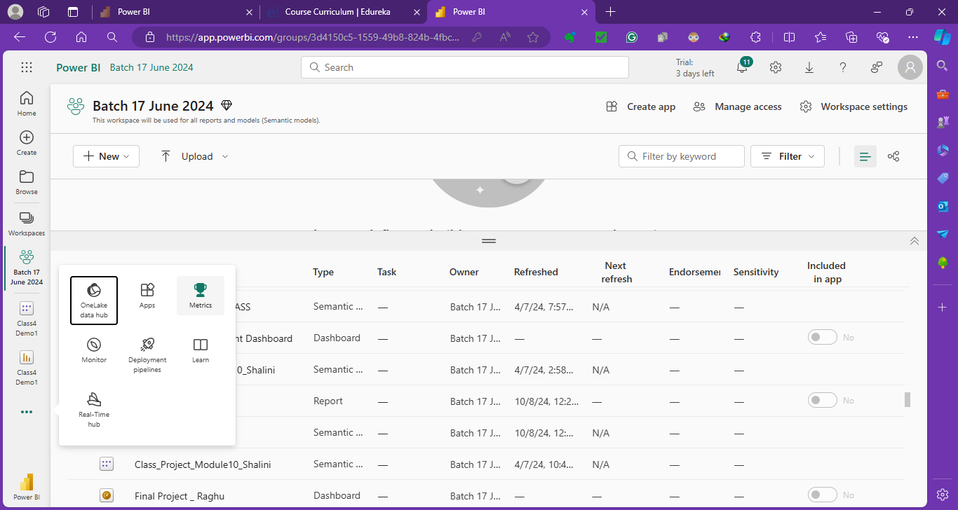
New Score card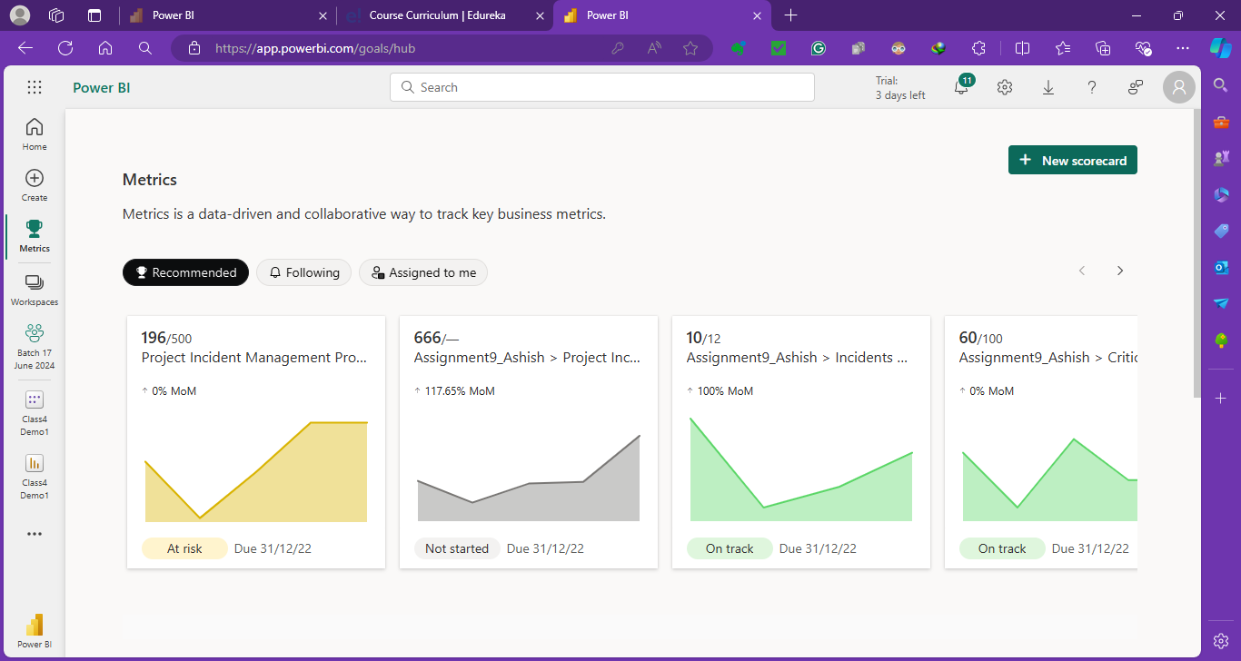
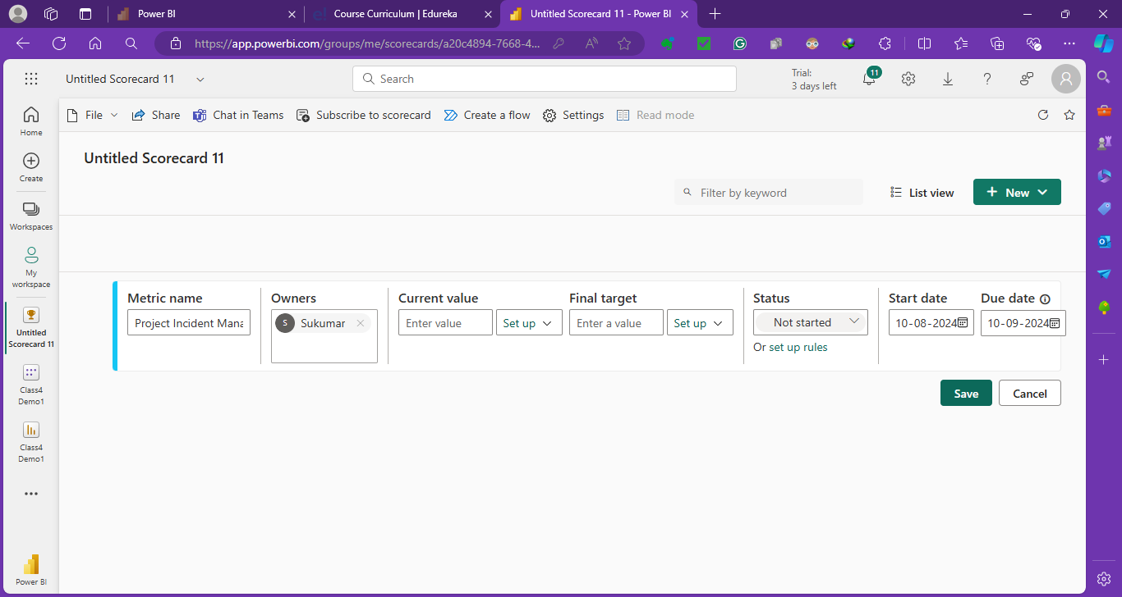
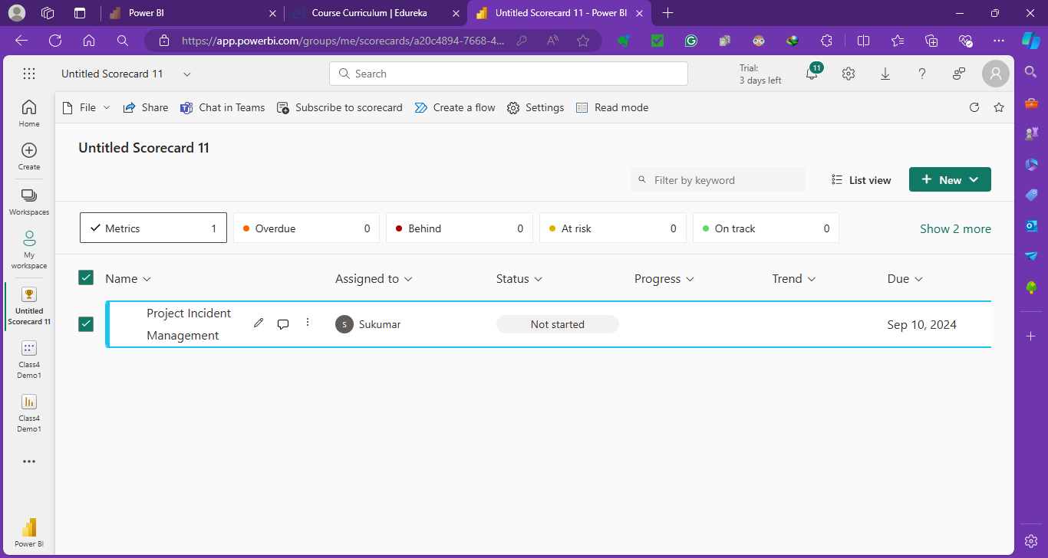
Add sub metrics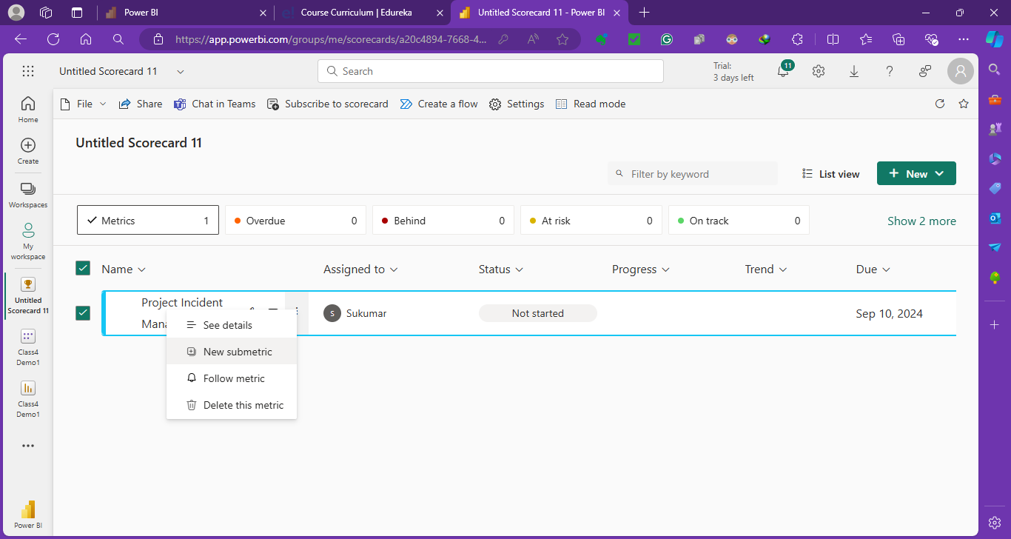
All sub mterics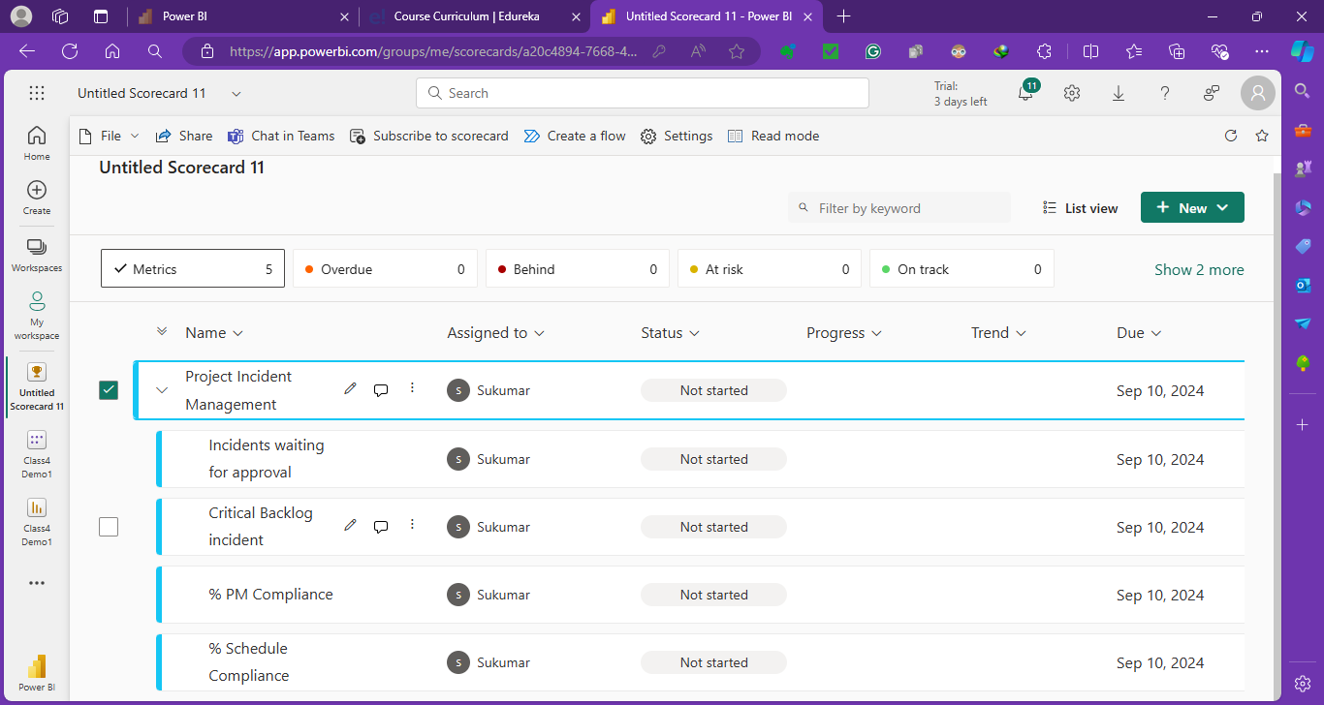
Edit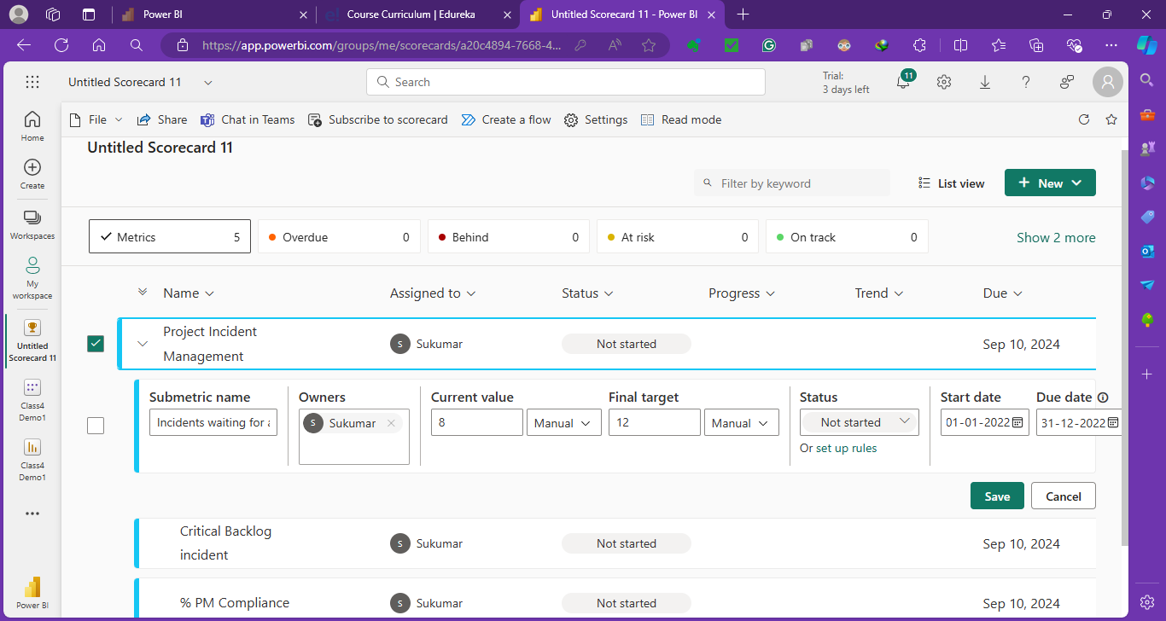
Setup Rules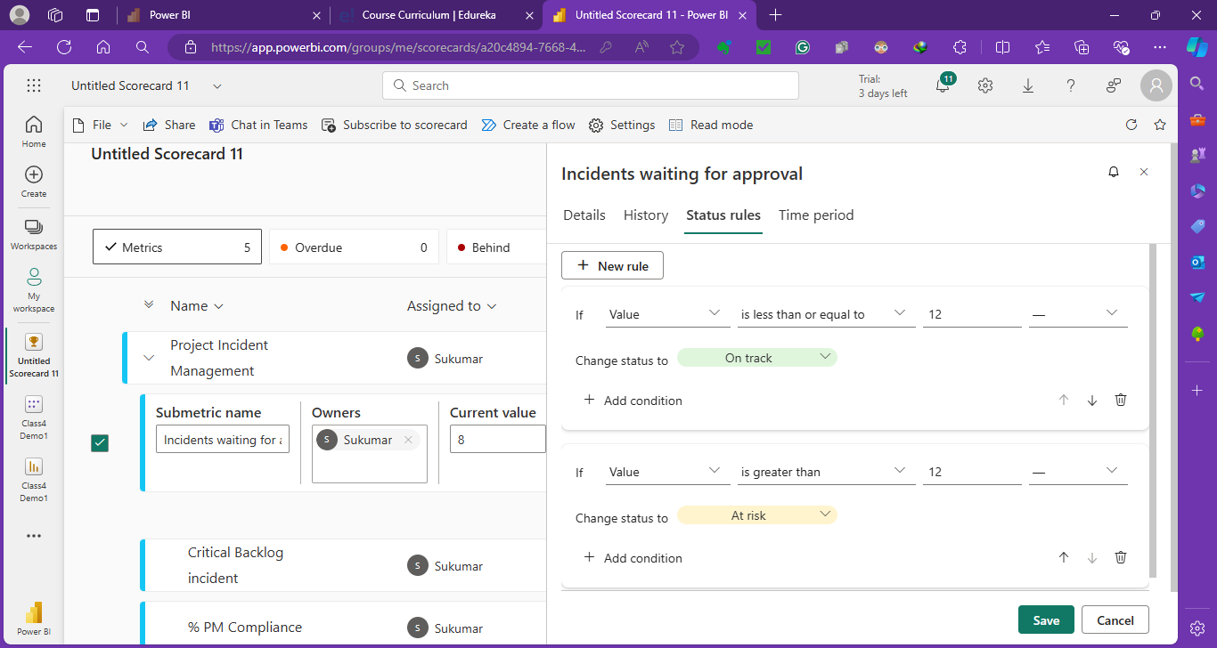
Adding details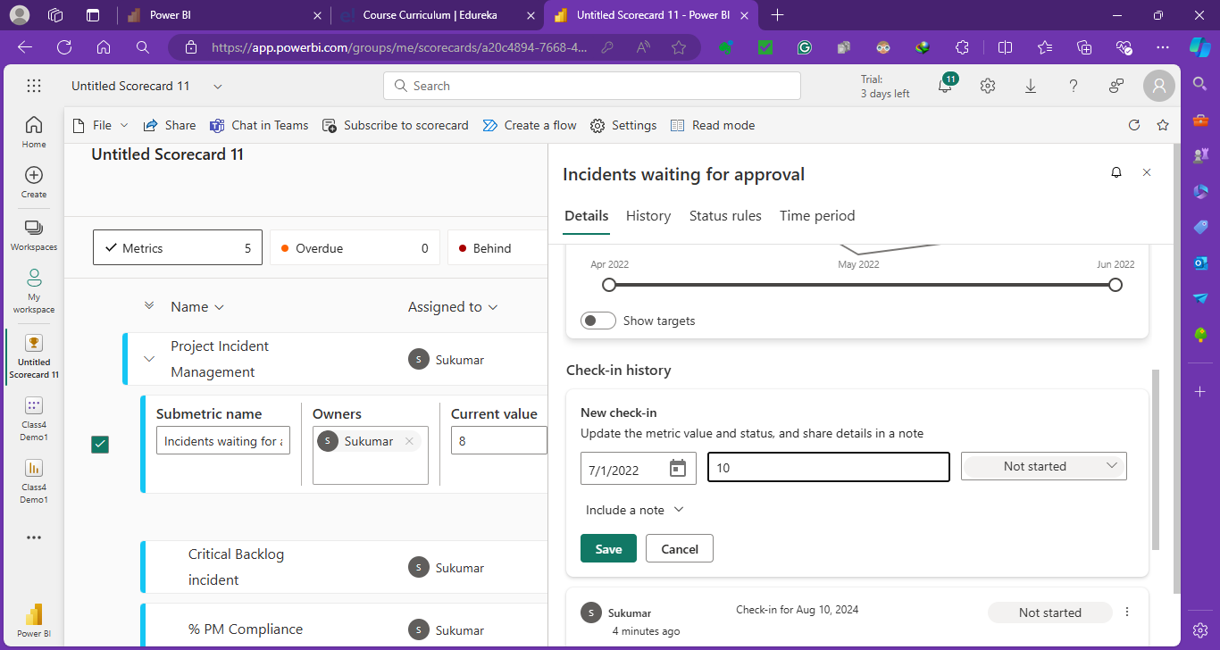
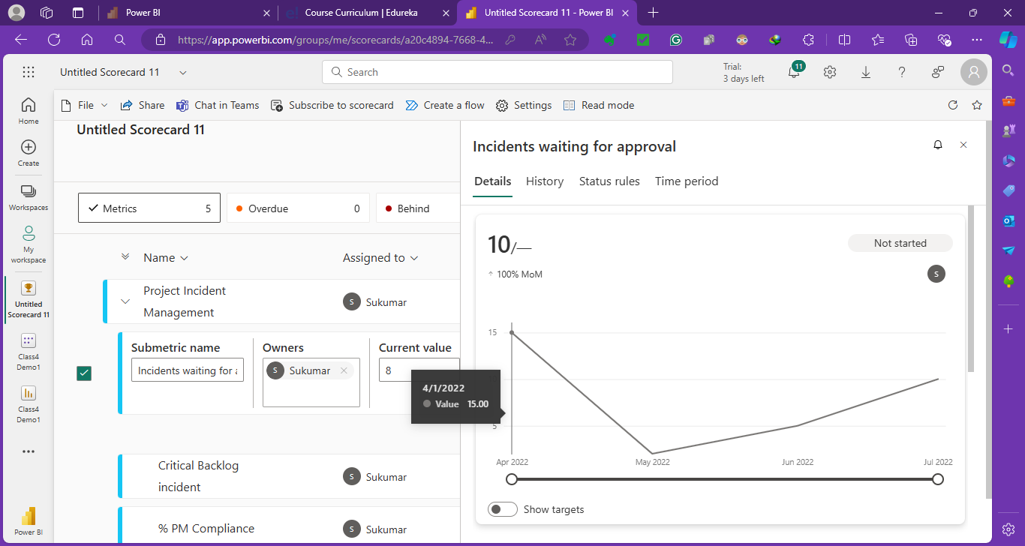
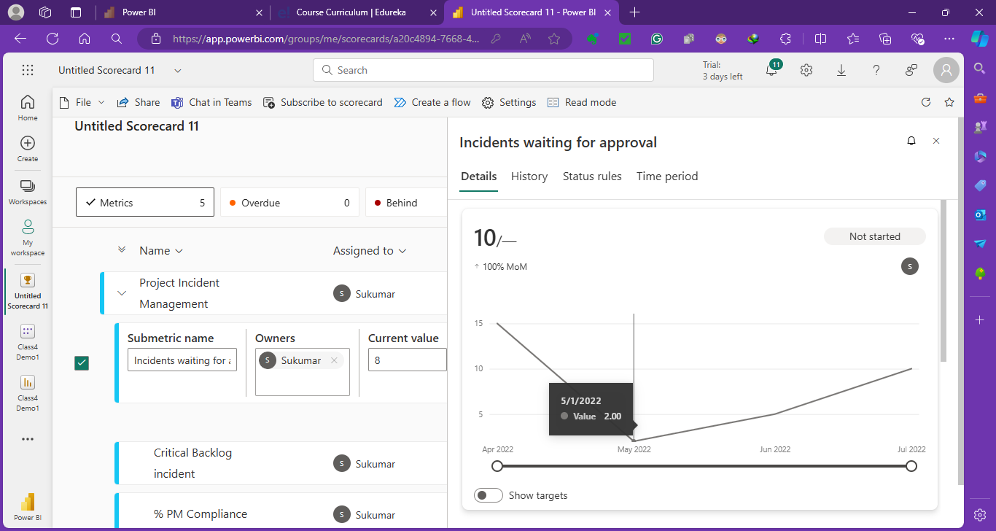
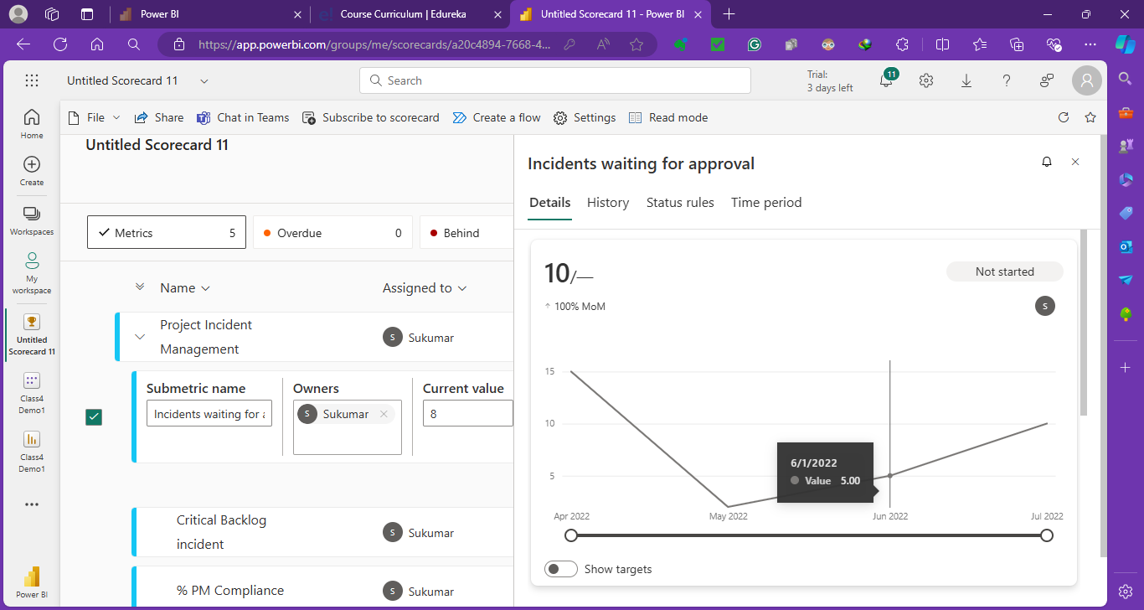
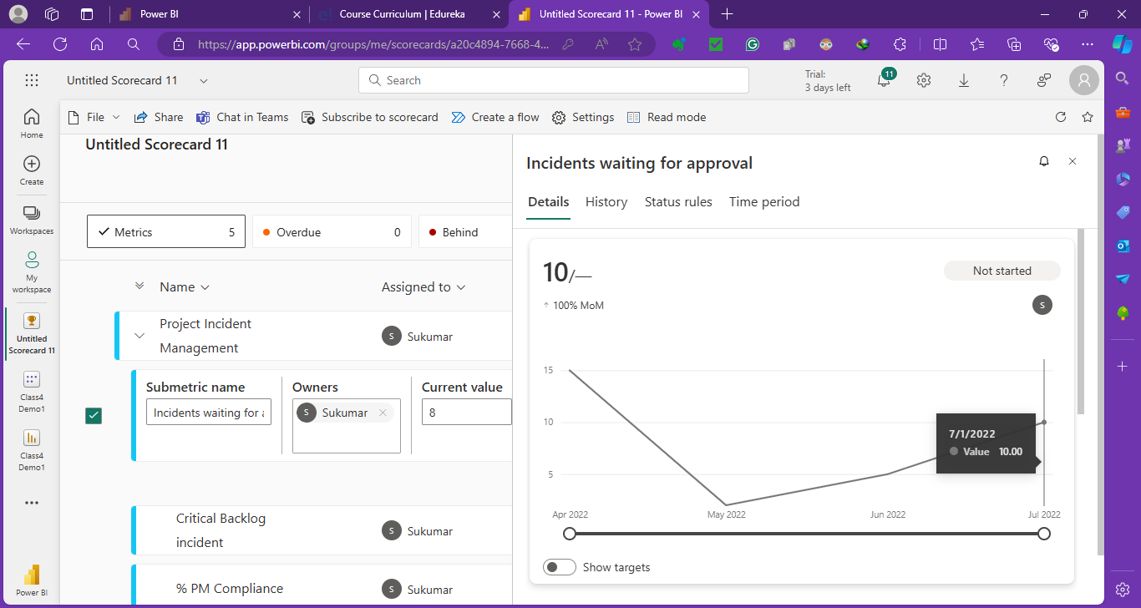
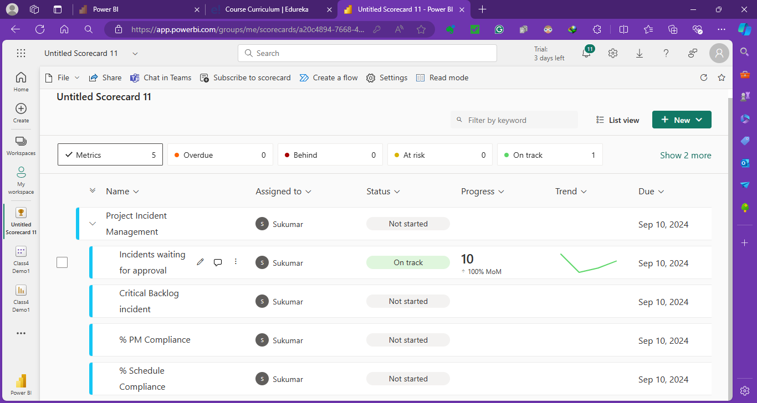

3. Edit the second subgoal Critical Backlog incident.
  - Provide the current value as 60 and give target values of 100.
  - Select start and end dates as the start of the year and end of the year, respectively, for the year 2022.
  - Set up rules for status.
    - On track: If the value is less than or equal to 80.
    - At Risk: If the value is between 80 and 100.
    - Overdue: If the value is greater than 100.
  - Go to the details tab and enter the following values for each month’s check-in:
    - For 1st April, set the value as 100
    - For 1st May, set the value as 20
    - For 1st June, set the value as 120
    - For 1st July, set the value as 60
    - For 1st August, set the value as 60
- Save your sub-goal / sub metric.

Edit Critical Backlog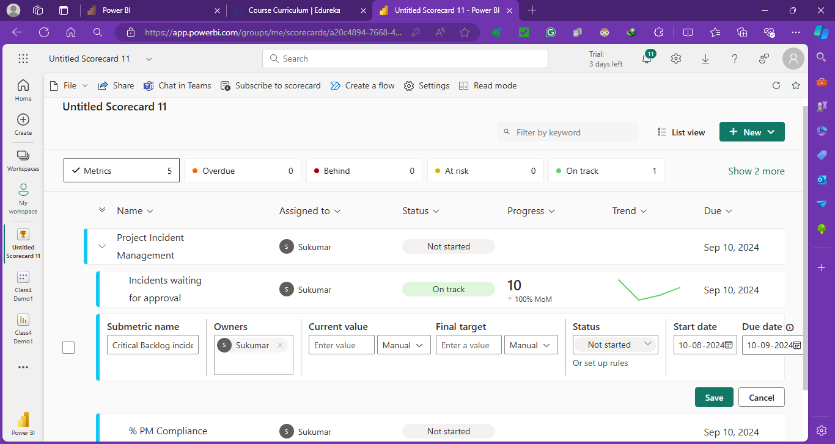
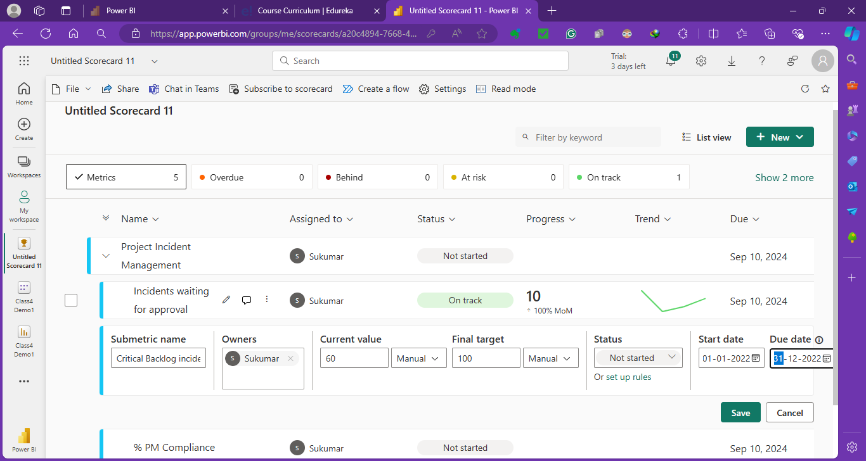
Set up Rules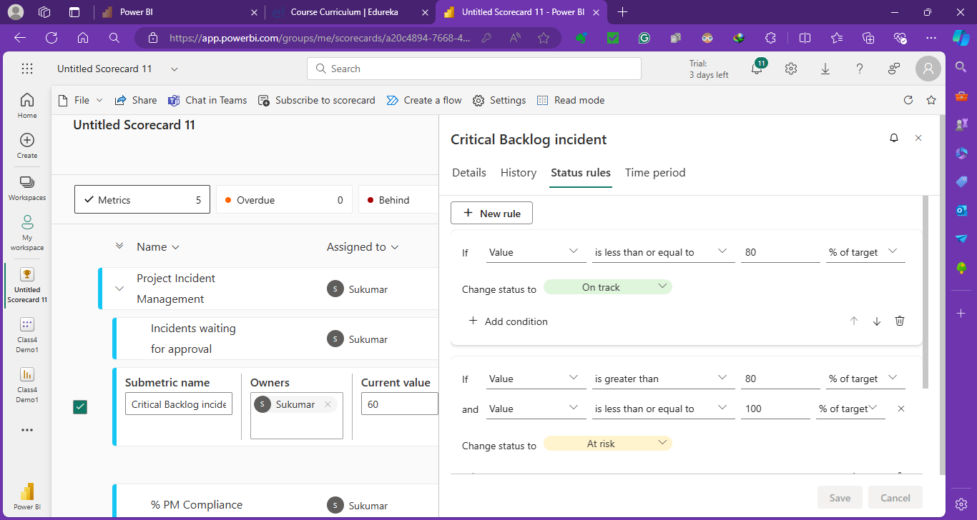
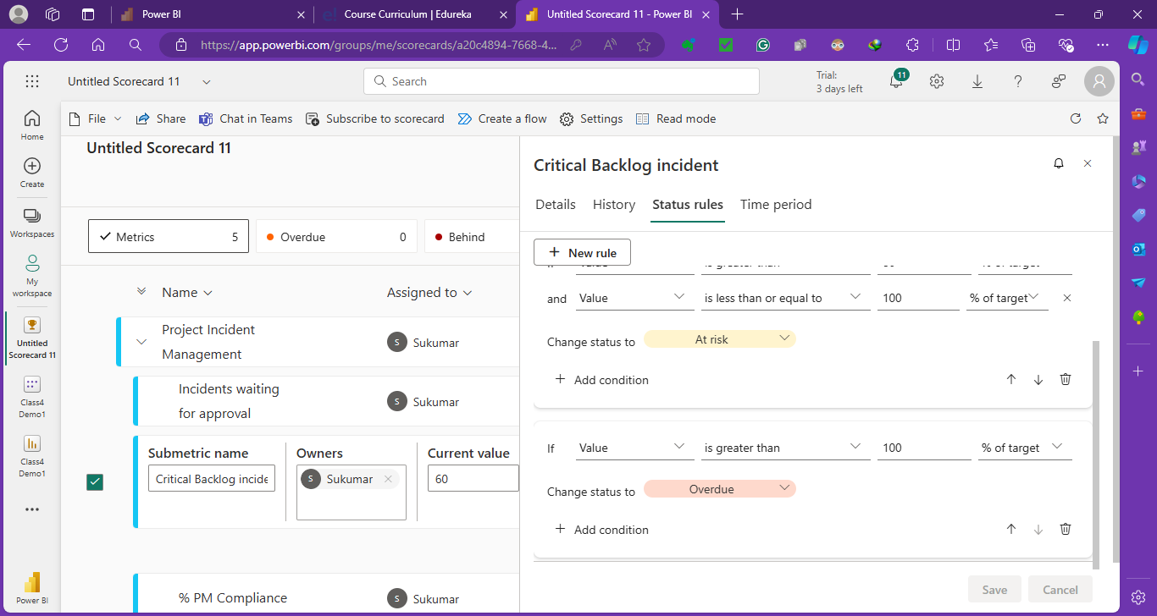
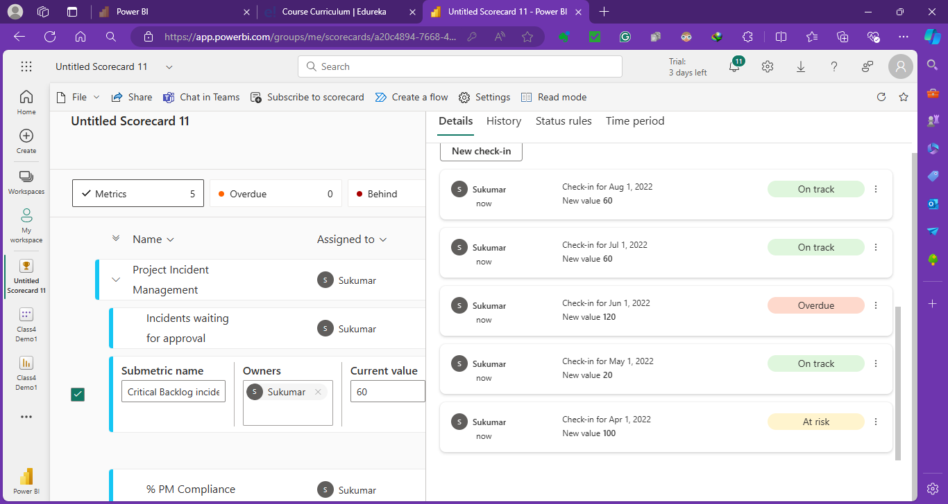
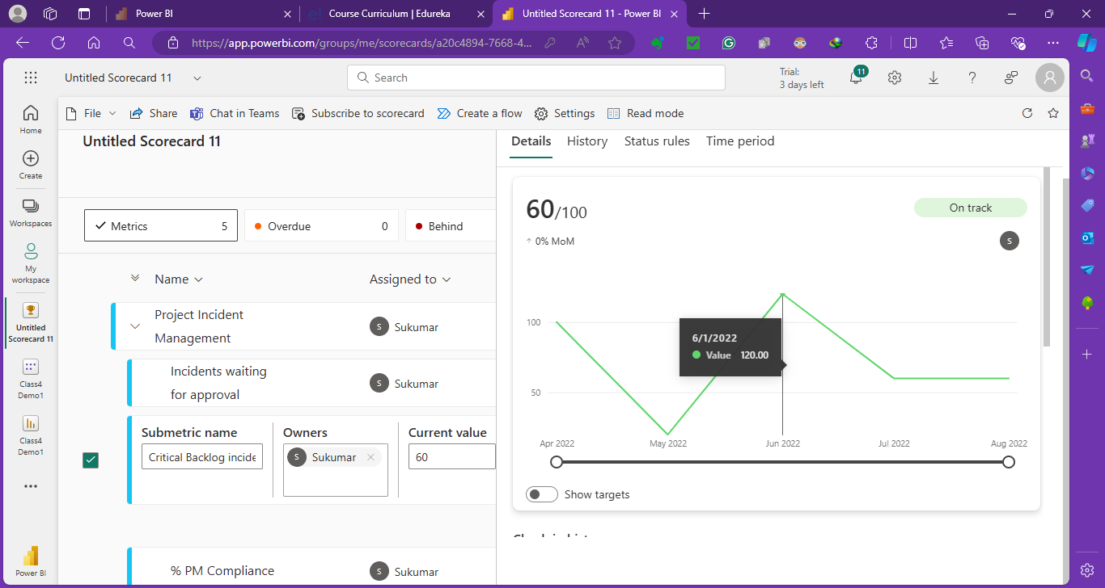
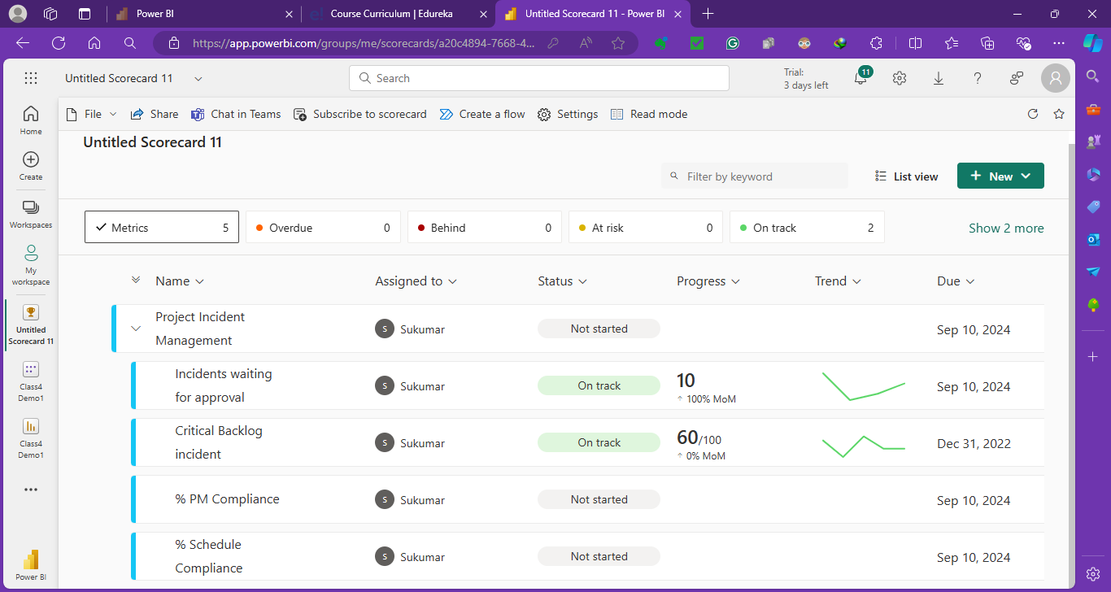

4. Edit the third sub-goal / sub metric % PM Compliance.
- Provide target values of 500.
- Select start and end dates as the start of the year and end of the year, respectively, for the year 2022.
- Set up rules for status
  - On track: If the value is greater than 10 % of the target
  - At Risk: otherwise
- Go to the details tab and enter the following values for each month’s check-in:
  - For 1st April, set the value as 40
  - For 1st May, set the value as 20
  - For 1st June, set the value as 20
  - For 1st July, set the value as 40
  - For 1st August, set the value as 400
- Save sub-goal / sub metric.

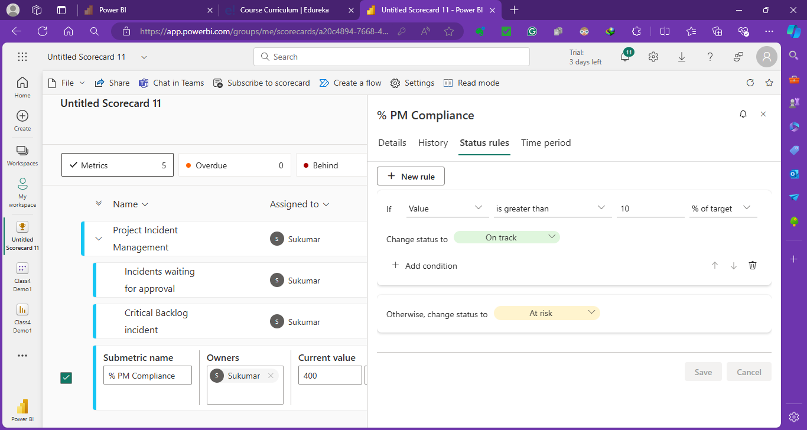
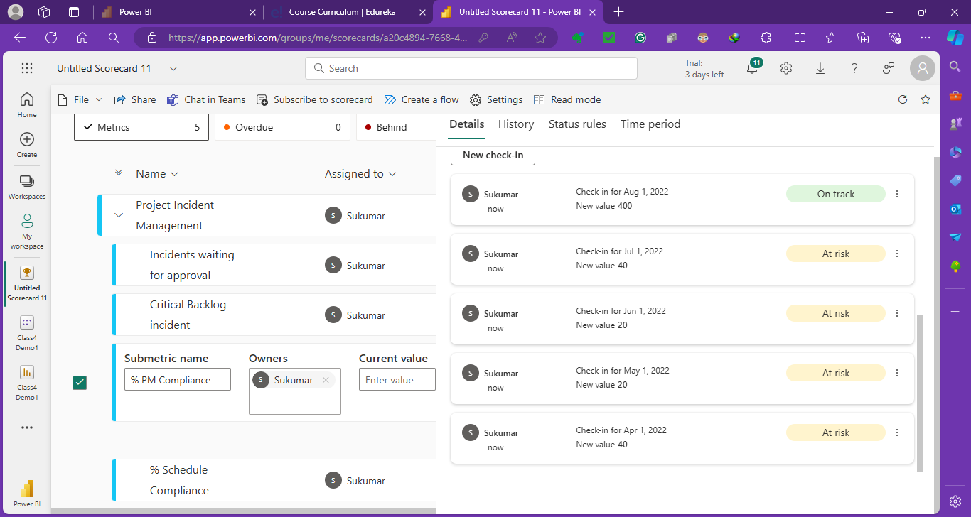
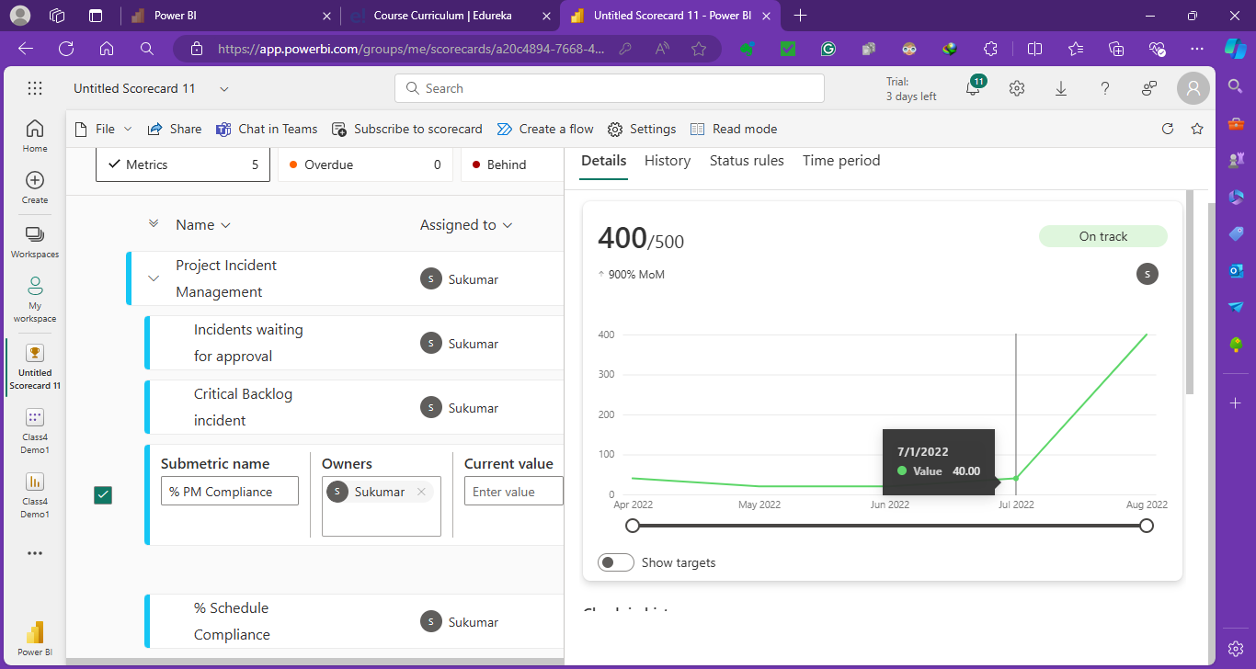
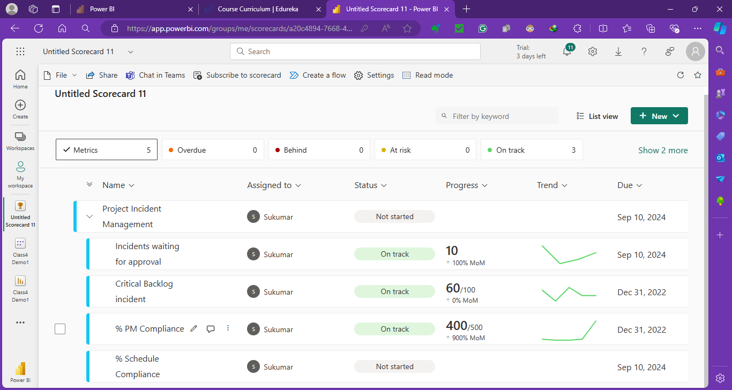

5. Edit the fourth sub-goal / sub metric % Schedule Compliance.
- Provide target values of 500.
- Select start and end dates as the start of the year and end of the year, respectively, for the year 2022.
- Set up a rule for status.
  - On track: If the value is greater than 80 % of the target
  - At Risk: otherwise
- Go to the details tab and enter the following values for each month’s check-in:
  - For 1st April, set the value as 158
  - For 1st May, set the value as 103
  - For 1st June, set the value as 148
  - For 1st July, set the value as 196
  - For 1st August, set the value as 196
- Save your sub-goal / sub metric.
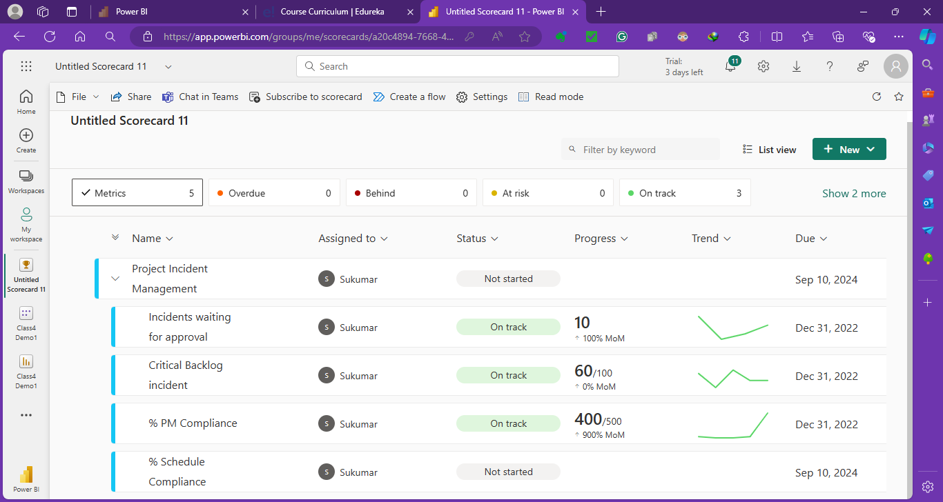
Set up Rules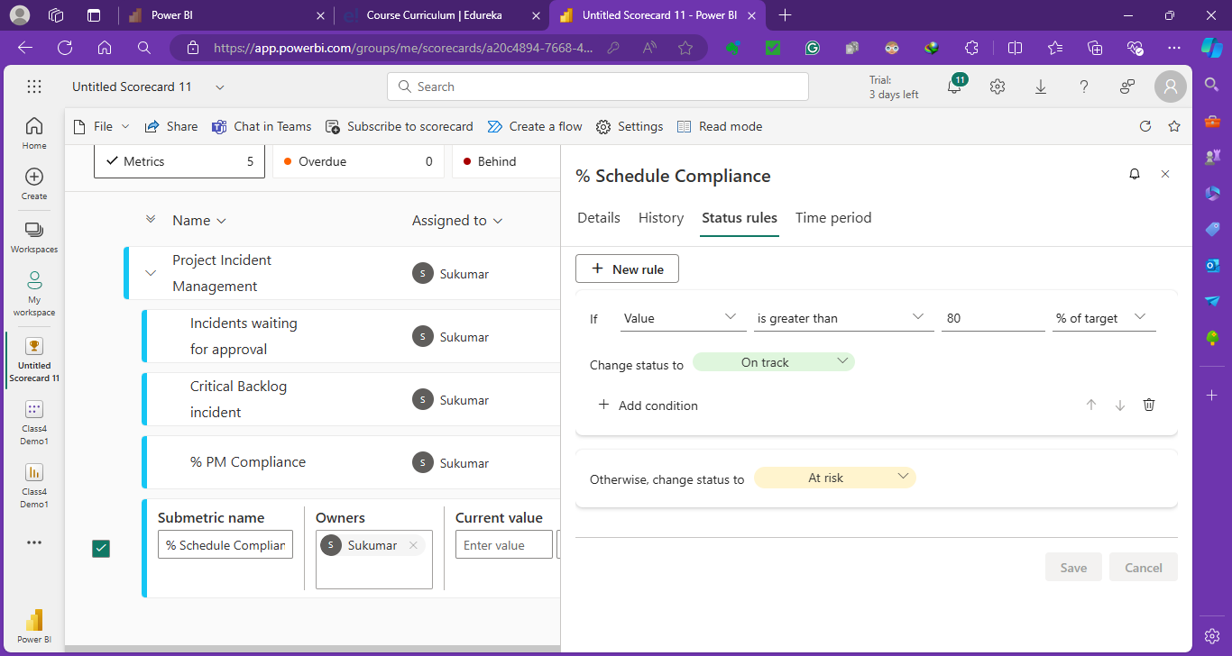
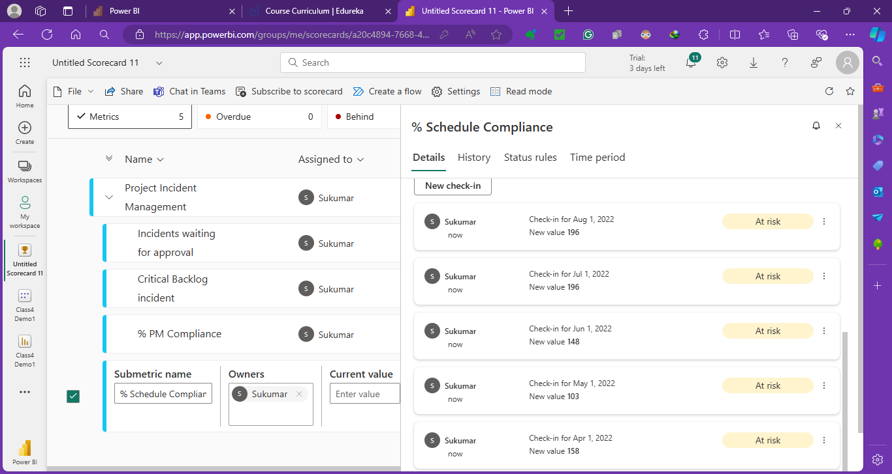
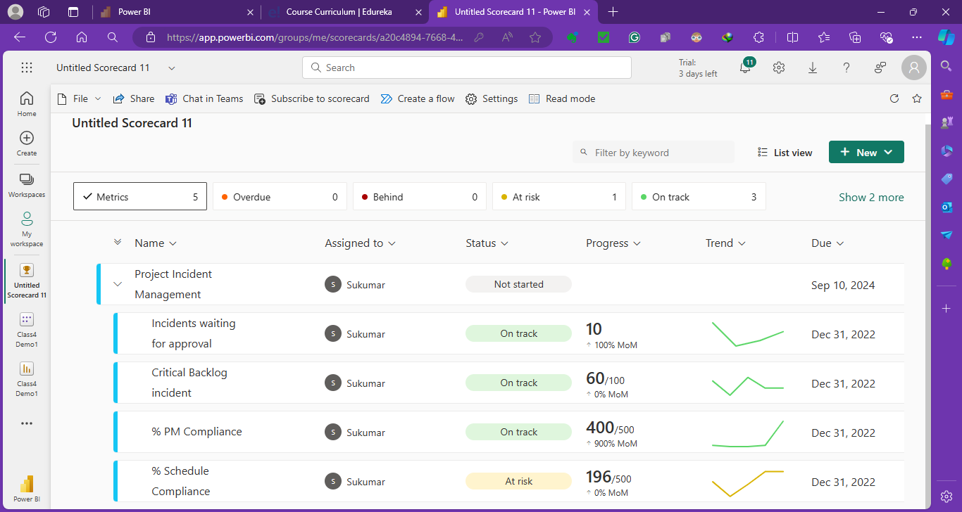
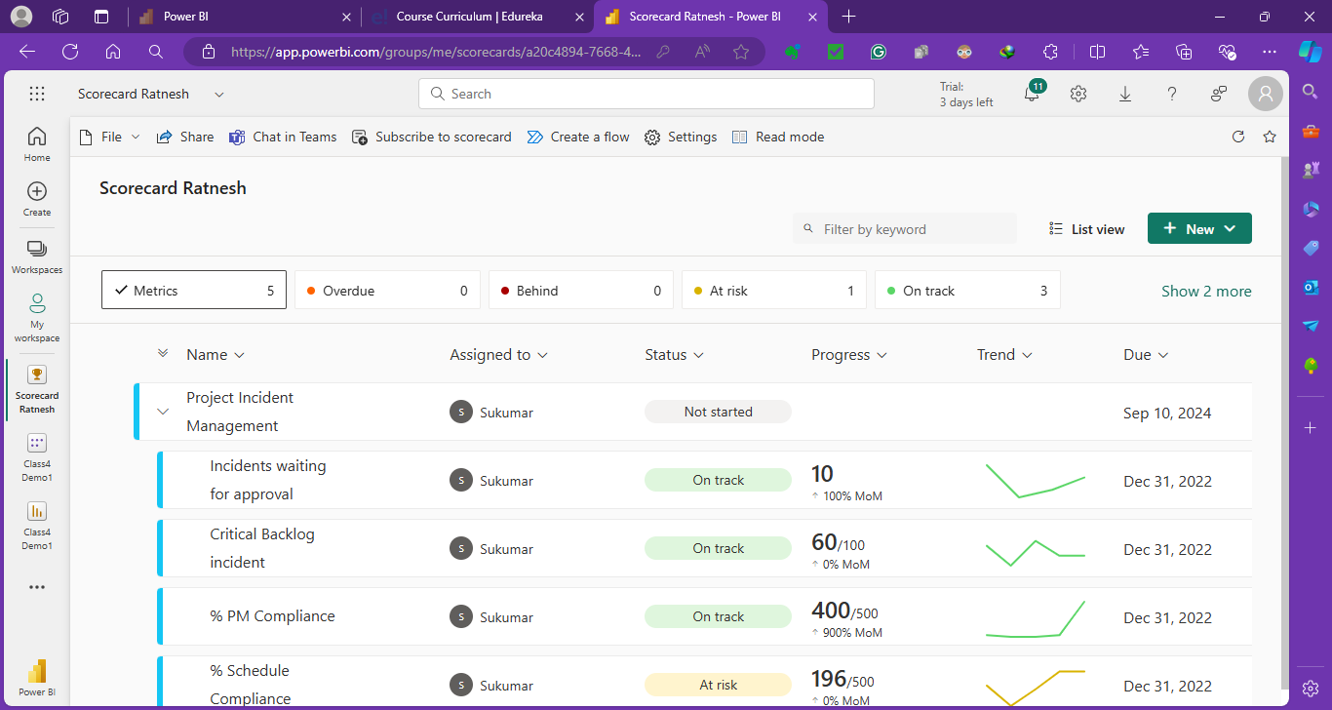
Updated Scorecard
